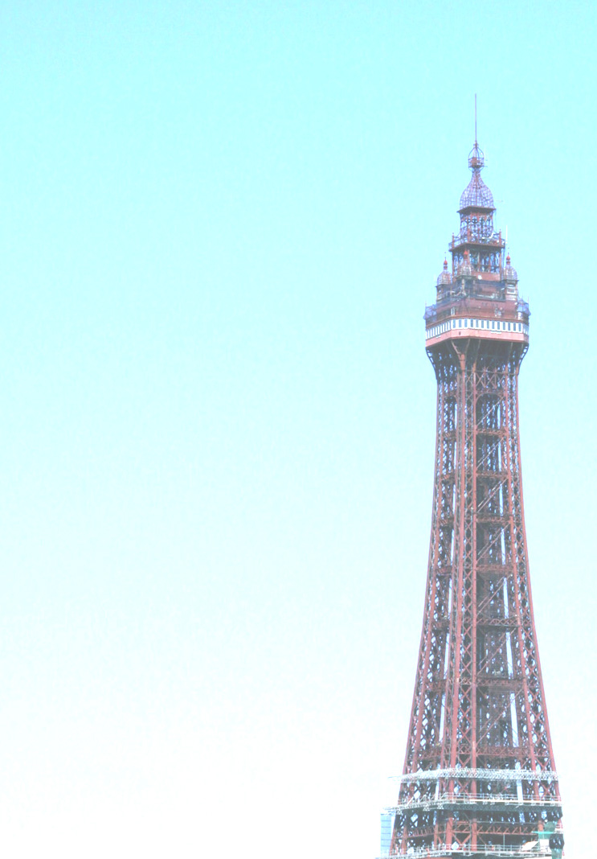
Travelling by train at half term
The Blackpool one-here we go
Windows scanned as it starts to slow,
Dash for the doors as the train is stopped
And those alighting are squashed in the crush.
No seats in sight-we’ll have to stand
No space for the luggage close at hand.
Blood pressure rises through stress and from strain
As we push and shove down the length of the train
and tread on toes and trip on cases
resenting invasion of personal spaces.
We stand close together with faces averted
For fear of being thought of as fresh or perverted;
The ones who are small point upwards for air
The ones who are tall get more than their share.
The babies are crying, children get factious,
Parents embarrass whilst others get cross-
and the rest of us try to ignore all the fuss
by trying to read other passengers books
or peer at their screens or admire their good looks,
and then there’s the smell of the vinegar crisps
and smell of filled nappies and sweaty armpits,
and the impossible traffic of families who
About Anne Etherington
A Lancastrian passionate about the arts- loving the cinema link in Hebden Bridge that allows greater access to live theatre, opera and ballet.
Anne is an artist and taught art in secondary schools in Lincolnshire before moving on impulse to Hebden Bridge.
She attempts to create mood and atmosphere in her poetry and finds inspiration for writing from people, personal experiences and the natural landscape.

again and again squeeze through to the loo.
Oh the joys of traveling at half term by train
Have encouraged me back to the car once again.
Anne Etherington
